Fraud Detection Dashboard
Wisdom Mike- Abuja, February 2026

- Project Overview
This project analyzes a banking transaction dataset to fraud patterns.
Goal: Identify high-risk locations, devices, and transaction types to help fintech/banking teams reduce losses, built end-to-end with excel (cleaning), MySQL (Storage & queries), Power BI (Visualization).
- Tools & Technologies used
- EXCEL: Data cleaning, initial exploration, calculated columns (e.g. amount)
- MySQL: Database creation, table schema, data import, complex queries (GROUP BY, SUM, Fraud rate calculations)
- POWER BI: Data connection (MySQL), DAX measures (Fraud rate), interactive visuals (KPIs, bar charts, donut charts)
- Data Source and Preparation
- Rows: 44,135 transactions
- Cleaning in Excel: Removed duplicates, handled missing values, formatted columns, added fraud label
- Imported to MySQL table
- Key columns: transaction_id, user_id, transaction_amount, transaction_type, time_of_transaction, device_used, location, payment_method, fraudulent (0/1)
- Key Analysis and insights.
- Total transactions: 44,114
- Total fraud cases: 2,168
- Overall fraud rate: 4.91%
- Highest fraud by location: Chicago (top), then Los Angeles, Boston etc
- Highest fraud by device : Mobile (31.83%), Desktop (29.89%), Tablet (29.24%)
- Highest fraud by transaction type : Online purchase (20.76%), Bill payment (20.43%), Bank transfer (20.16%).
- Visuals and Dashboard
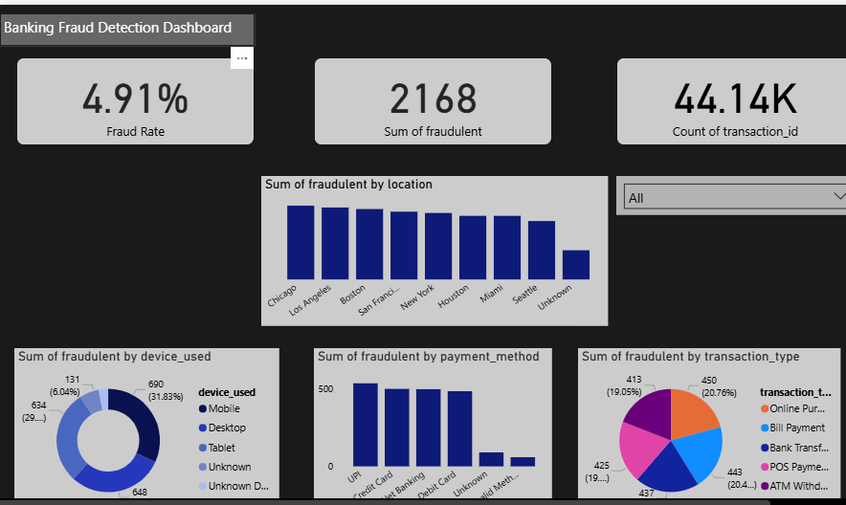
- Challenges and Solutions
Aggregated issues- Changed to sum for fraudulent column
Row count mismatch ( 43.27k to 44,135)- Fixed by switching from count distinct to count on transaction id.
- Conclusion

